Optical Control Sensor

**Department of Electrical Engineering and Computer Science**

**University of Central Florida**

**Group 29**

Timothy Wells - Electrical Engineer

Patrick Gonzalez - Computer Engineer

Mchael Fillinger - Computer Engineer

James Curtis - Electrical Engineer

**Sponsors / Contributors / Customers**

None as of Yet

*Due date*

9/20/2019

**Project Narrative**

Motivation

In today's technology, there are many untapped or unutilized input sources for a person to further interact with personal devices like a heads up display. These inconvenience causes the user to have to learn or rely on non-intuitive control systems for interacting with said device. The idea is to allow both device and user to share line of sight of the task that lies in front of both of them. By developing a low-cost, hardware based solution, we hope to make eye-tracking an easier to approach and more viable solution.

Goals/Objectives

In developing this project, our main purpose is to create a portable fast acting control system that uses the operator’s eye position/ state to control another external device with line of sight from inside the device. By using an array of light-sensitive sensors, we hope to be able to use the data from the sensors to then determine where the user is looking in frame to what the device the user is trying to use. The idea of using an array of sensors as opposed to a camera is so that the device will consume less power and will not need to process as much data. The objectives of this device are as follows:

* Create an array of sensors around each eye
* Convert the data to a digital signal to be read by a microcontroller
* Develop an algorithm for the microcontroller to determine the eye’s position
* Use the eye’s position to send commands to camera system to move the camera

Eye tracking

The principle behind the concept of how this system tracks the user’s eye in real time is through the use of LDR, or Light Dependent Resistors, set up in an array structure floating around the user’s eye measuring m.. changes in and around the eye. These sensors use the light created from a display inside a helmet or mask incoparasin to the same light reflected from the users eye to read changes in positions of the eye. The user will control a camera arm through the line of sight of the arm. As the user looks up through the arms video display, the arm will respond back by also looking up. Vice Versa for the cases for directional movement.

**Project Requirements and Specifications**

* Ability to track eye movement
* Convert an Analog Signal to a Digital Signal
* Simple to Start Up and Use
* Weight of Device to track Eye Movement < 5 lbs
* Ability to view through the Robot Arm’s Camera with the Eye Tracking Device
* Ability to move the Camera on the Robot through Eye Movement
* Device used to track Eye Movement must be Adjustable for Comfort for the User
* Weight of Robot Arm < 10 lbs
* Robot Arm able to rotate Horizontally 360 Degrees
* Robot Arm able to rotate Vertically 90 Degrees
* Camera and Robot Arm must be very responsive
* Ability for Data Transmission via Wifi for Wireless Eye Tracking Device
* Dimensions for Eye Tracking Device: Can be adjusted from 53 cm to 61 cm of circumference

**Possible Project Constraints**

1. Device must cost less than $500 to produce
2. The two devices might lose or lag connections due to limitations of wifi
3. LDRs might need calibrations per use of the device
4. The mask or goggles part of the device will need to be clean for optimum use
5. The difference in reaction times between both devices

**House of Quality Diagram**

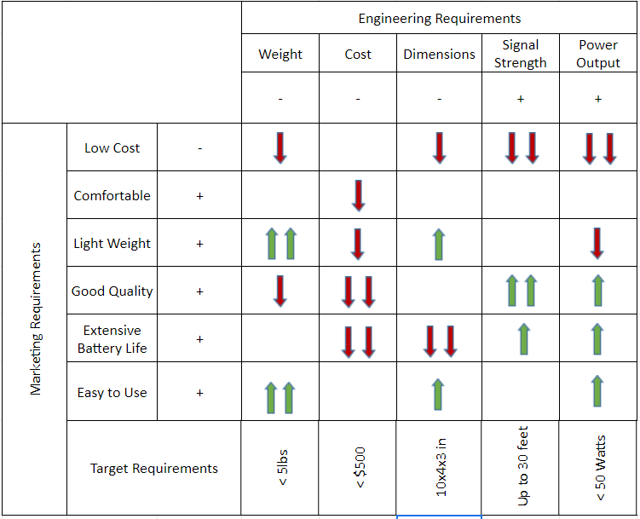

**Block Diagram**

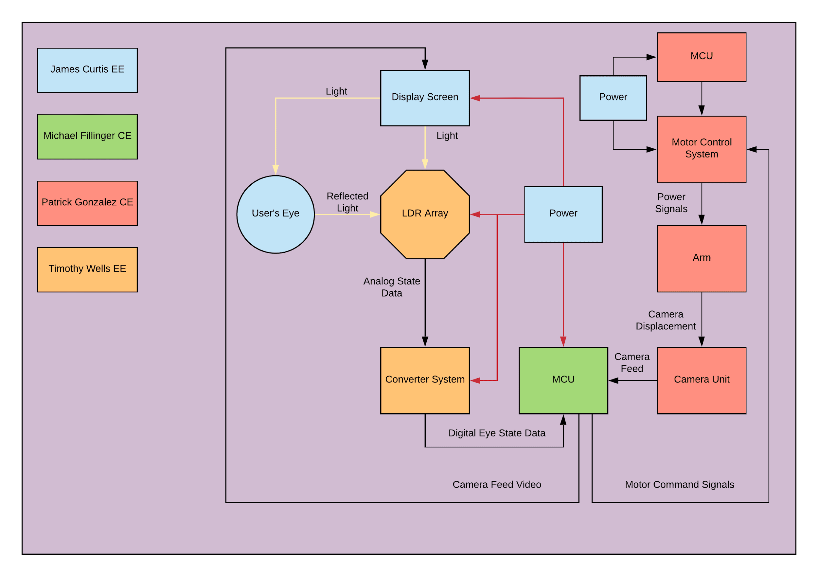

The device is split into two devices One is the LDR goggles, the other is the arm/turret the goggles control. The arm is mostly perbuild components while the LDR system will be built from the ground up, besides the MCU and display. The two devices will communicate through wifi between the two MCU.

**Estimated Budget**

|  |  |  |
| --- | --- | --- |
|  | Quantity | Cost |
| LDR | 16 or more | $0.20 Each |
| Camera  (Web Cam) | 1 | $50.00 |
| Display screen  (24 inch HDMI LCD Screen | 1 | $145.00 |
| Development board  (Raspberry Pi 4) | 1 | $100.00 |
| Robot arm (LewanSoul Robotic Arm) | 1 | $200.00 |
| Total |  | $400.00 |

**Project Milestones**

